[Type text]

[Type text] [Type text] [Type text]

JTDX User Guide

JTDX ©by HF Community Igor UA3DJY and Arvo ES1JA
It is modified WSJT-X software forked from WSJT-X r6462.
JTDX supports JT9, JT65, T10 and FT8 digital modes for HF amateur radio communication, focused on DXing and being shaped by community of DXers.
© 2016-2017 by Igor Chernikov, UA3DJY and Arvo Järve, ES1JA

It is created with contributions from:
DK7UY, DO1IP, ES4RLH,G7OED, MM0HVU, RA4UDC, SV1IYF, UA3ALE, US-E-12, VE3NEA, VK3AMA,
VK6KXW, VK7YUM and LY3BG family: Vytas and Rimas Kudelis.

JTDX Support Group JTDX on the Web
JTDX YouTube JTDX T10

JTDX is licensed under the terms of Version3 of the GNU General Public License (GPL) https://www.gnu.org/licenses/gpl-3.0.txt
Language translations: German - DK7UY Spanish - LU9DO

A User Guide to JTDX and getting on the air quickly.

Table of Contents

- Foreword 4
- Overview of FT8 5
- Installing JTDX 6
  - JTDX.INI file 7
  - Desktop Shortcut Icon 8
  - CALL3.TXT 8
  - Logfiles 8
- PC Time Synchronization 9
- PC Soundcard Settings 11
- JTDX Control Panel 15
  - Waterfall Display 15
  - Main Control Window 16
- The Settings-Menu 23
  - General Settings 24
  - Radio Settings 27
  - Audio Settings 29
  - Sequencing 30
  - Tx Macros 31
  - Reporting 32
  - Frequencies 34
  - Notifications 35
  - Filters 36
  - Scheduler 37
  - Advanced 38
- The Main Menu 40
  - File 40
  - View 40
  - Mode 40
  - Decode 40
  - Save 41
  - AutoSeq 42
  - Misc 43
  - Help 44
- Merging internal logbook from WSJT-X with JTDX 45
- Supported 3. Party Programs 48
- JTDX on the Web 50

Foreword

This user guide is available by clicking the Help tab and selecting the Online User Guide.
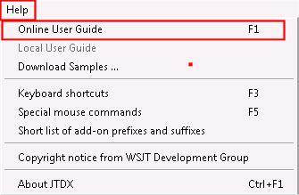

These are basic settings that should get you on the air. This User Guide will not include any technical information about the decoding algorithms or maths.
There are many different configurations – and each rig is slightly different, but, by methodically going thoughthrough the settings you can set your station up to be “just right”.

Assumption:

You are using the Windows operating system. These instructions are based on Windows because that is what I am using. Linux variations should be similar.
You have a radio and a soundcard that can be connected to your computer and radio (eg RigBlaster, Signalink etc.) Some of the newer radios have sound cards built in allowing direct input from the computer.
If you’re planning on using CAT control, then you have some form of cable that connects the radio and computer to allow this to happen. Also, that you have some software that will allow for CAT control of your radio (eg Ham Radio Deluxe, DX Labs Suite, Omnirig etc).

Overview of FT8

This mode was developed by WSJT Development Group unter Joseph Taylor, K1JT and is fast! You need to be on your game to keep up and it is quite easy to get overcome by the speed that it all happens.
A suggestion before you “jump in” –

watch, watch and watch some more!

You can learn a lot looking at how other stations are operating, what they are doing right, and wrong. Also, become familiar with Auto Sequencing and how it works within JTDX as it IS different to WSJT-X.

There is a complete section on Auto Sequencing and it WILL help you to read it – probably a few times – to let it settle in your mind and which settings suit your style of operating.
Above all, have fun!

Installing JTDX

The installation of JTDX is very straightforward, you start by clicking on the instillation file, for example JTDX-18.1.0.63-win32.exe.

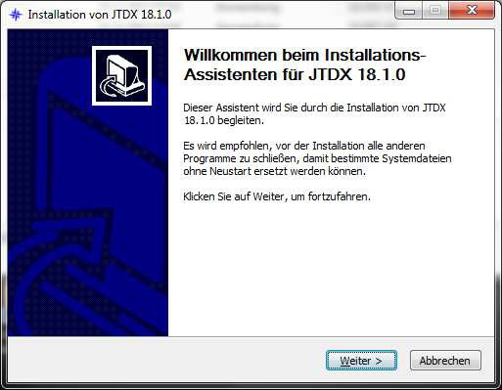
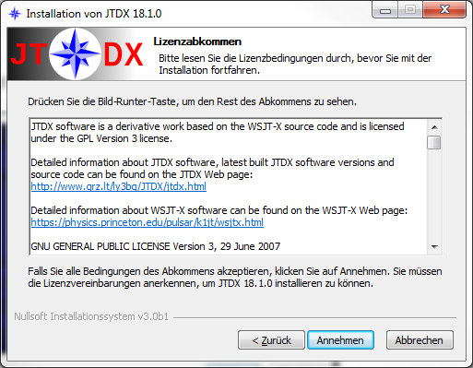
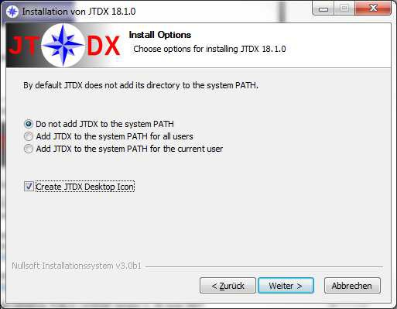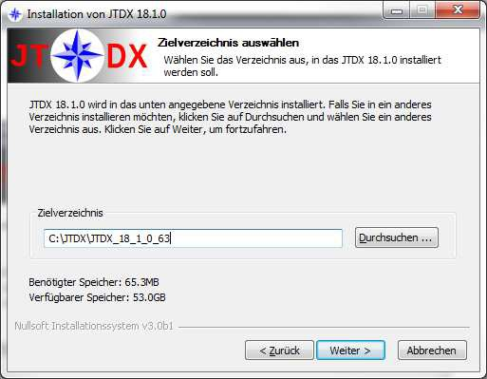

Mark checkbox to get an Icon on your desktop Use a new folder for every step you install
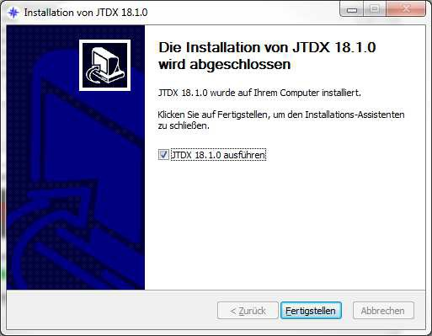
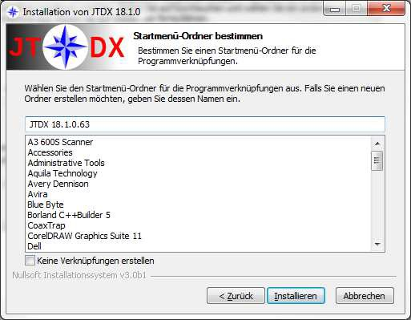

JTDX.INI file

The JTDX.INI file is responsible for configuration settings storage, to go to the folder with this file, open File - Open log directory

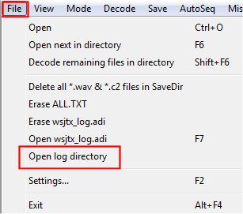
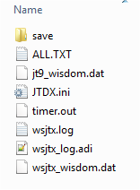

The Folder C:\Users\%username%\AppData\Local\JTDX containing the JTDX.INI file is created upon first run of software and will remain if software is uninstalled.
Data structure in this file may be different for various JTDX versions. JTDX.INI file compatibility with previous software version is shown in the release notes.
Upon JTDX software upgrade it is recommended to rename old JTDX.INI file, according to information from the release notes, all settings will reset to default values if this file is deleted.
This file may only be deleted if JTDX is closed, otherwise JTDX software will recover the old JTDX.INI file from the backup copy.

Desktop Shortcut Icon

If user would like to use various JTDX versions or multiple instances of the same JTDX software version simultaneously, shortcuts shall be used with ‘--rig-name=’ key defined in the shortcut properties to run the software.
This way every instance of the running software will be using own configuration settings and log, located in the folder defined by the --rig-name= key.

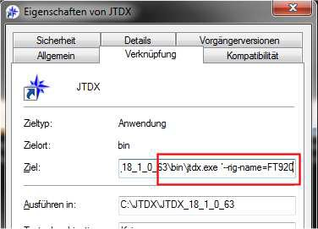

CALL3.TXT

HF CALL3.TXT file coming together with JTDX software, it contains callsign and grid data and being used for hinted decoders and detection of the false decodes.
You have to copy CALL3.TXT file in the log directory to get hinted decoders working. The latest version is for download at http://jtdx.tech

Logfiles

wsjtx_log.adi file is used for QSO logging, ADIF export from other logbook software can be used for JTDX if it is copied in the wsjtx_log.adi file.
Old wsjtx_log.adi and CALL3.TXT files shall be copied to the new log directory if upgrade from older JTDX software version to JTDX v18.x is performed.

PC Time Synchronization
It is important to keep computer synchronized -0.2…+0.5 second to the network, if every operator keeping similar time accuracy the maximum decoding performance can be achieved by JTDX software.
NTP client software shall be used for time synchronization, 5 hour time update interval would be good enough for most computers. Increased time update interval shall be used for unstable or low speed Internet connection.
Make sure there is only single NTP client software installed and running on your computer. There will be unstable time synchronization if multiple NTP clients are running simultaneously on the computer.
Make sure Windows automatic time synchronization is turned off.

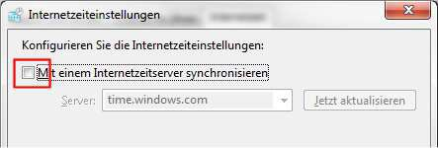

Antivirus protection software and poor quality Internet connection may cause delays in the Internet packet propagation and in result of this delay wrong time synchronization. Make sure that Internet packet analyzis is turned off in the antivirus software
Various NTP client software is available on the Internet, there is just an example of settings for the NetTime Version 3.20 Alpha 1 software.
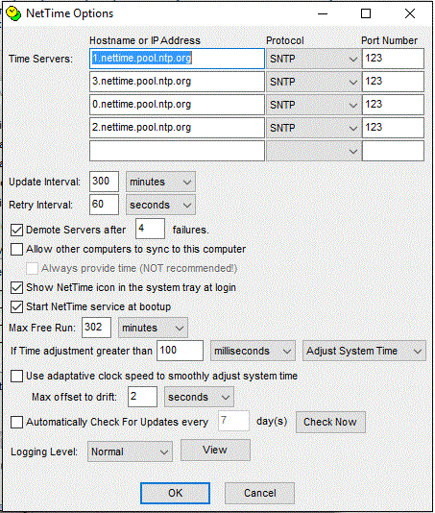

You may change the Time-Server Hostname to an NTP-Server close to your location to avoid runtime delays.
If time offset after automatic time update is greater than 100 ms, manual time update by Update now button can be used to bring time offset below the 100 ms value.
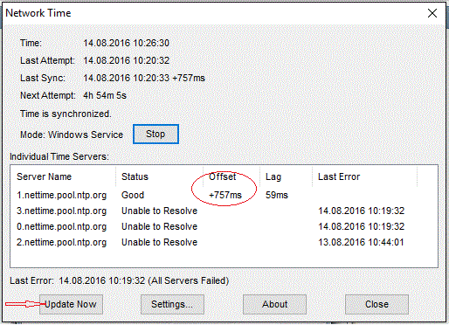

If you are seeing signals on the waterfall but are not decoding any, then check your clock!

PC Soundcard Settings

JTDX software works with 48 kHz sampling rate and 16 bit depth audio stream. To avoid re- sampling and decoding performance degradation it is recommended to configure input and output (recording and playback) of audio device in the operating system using this settings.
To configure it in MS Windows 7/8/10 open audio devices:
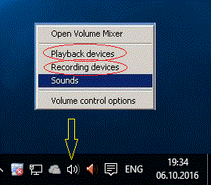

Adjusting Soundcard Output (TX)
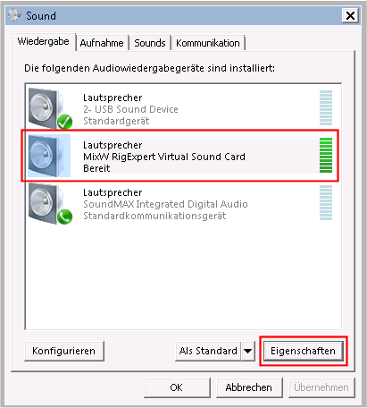Choose audio device you would like to use for JTDX and go to the Properties - Advanced tab.

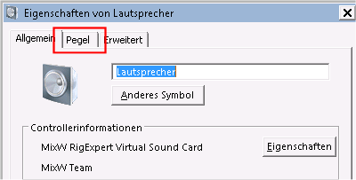
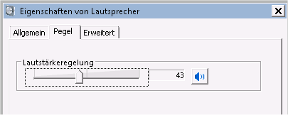
Adjust the soundcard Output that the ALC of the connected Radio will not exceed the limit stated in the Radio’s user manual.

It’s a hard to overcome the myth that ALC should be 0 and every move of the ALC needle is evil …

Switch off any Compressors or DSP equalizers on the radio!

Most modern rigs have a Monitor function to listen to the transmitted signal, use it to ensure your modulation is loud, but not overdriven!

If you have a friend in the neighborhood, let him have a look at your signal, but be aware that receivers could be overdriven too.

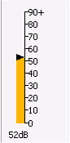Soundcard Input (RX)

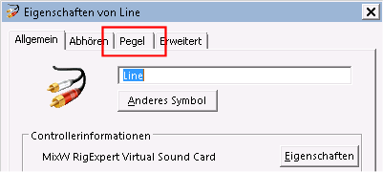
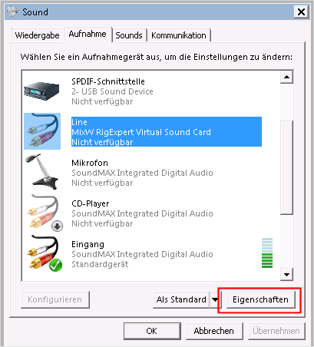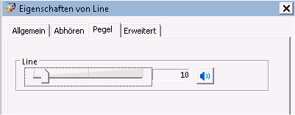Choose the correct input device and click on Properties – Advanced.

Adjust the soundcard Input that the level of the JTDX Audio Input Meter will be between 30 and 50 db.

The same settings shall be applied for virtual audio cable, if it is used for SDR transceiver or Web SDR receiver connection to JTDX.

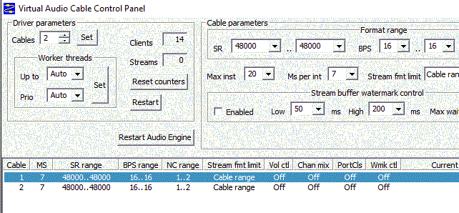

If there is only single sound card installed, MS Windows operating system will configure it as default audio device and some other application like Web browser or Skype may change sampling frequency of the sound card leading to the JTDX decoding performance degradation.

JTDX Control Panel

Waterfall Display

If the waterfall controls are missing, check if the checkbox is enabled.
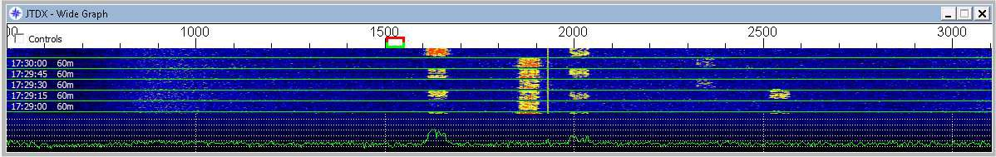

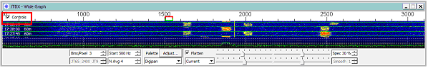These are the settings I prefer:

- Bins/Pixel = 3
- Start 500 Hz
- Palette: Digipan
- Flatten: Selected
- Waterfall Gain: 1 tick to the left

With these settings the signals between 500Hz and 3100Hz in your RTX bandwidth will be decoded.

Main Control Window

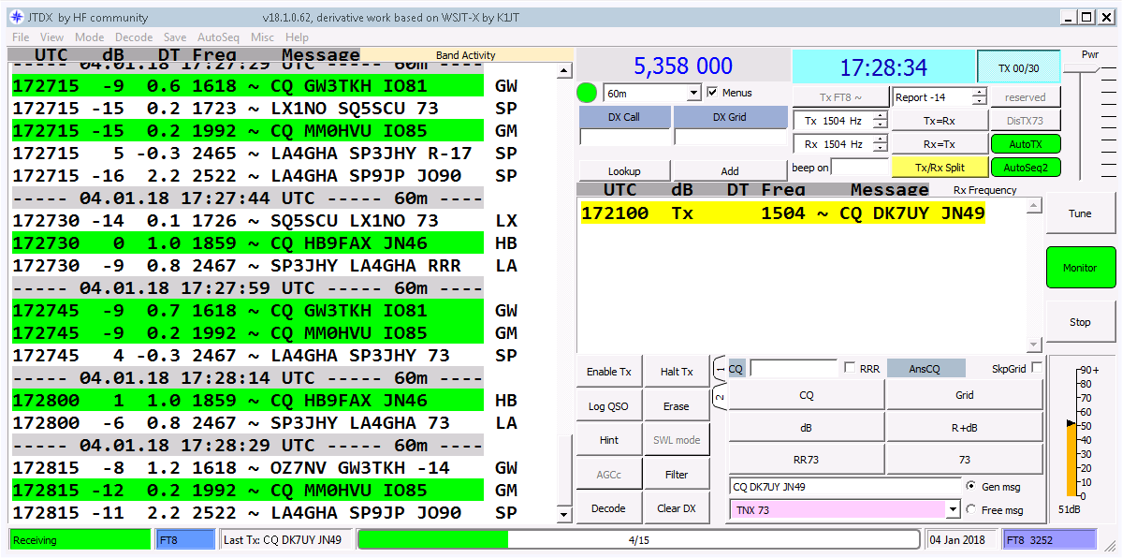

The Main Menu, we will go through the different points step by step.

Receive window, here you will see all decoded messages.
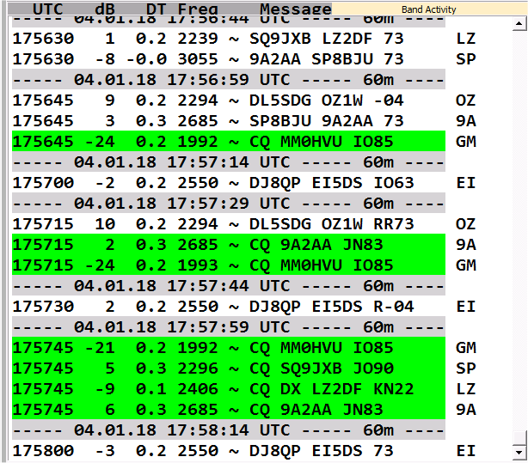

Main Control Panel
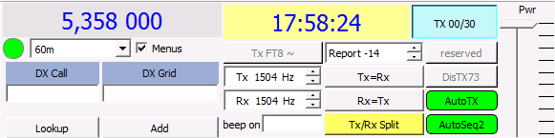
Operating frequency, can be selected by drop-down menu
Switches Main Menu on/off
Switches time sequencing between Odd/Even
UTC-Time
Setting of TX Output power, slide this UP after installation.
Default will set your Output to Milliwatts only!
Select if double click to a decoded signal should enable TX
Shows selected callsign and grid locator.
Shows TX and RX frequency offsets
Sets TX to RX frequency or RX to TX frequency when in Split-Mode
Switches between Split-mode on/off (Default = Split)
Switches Auto-Sequencing on/off

Secondary Receive Window, this will show decoded signals including your callsign only. Also your transmitted messages will be shown here if selected,
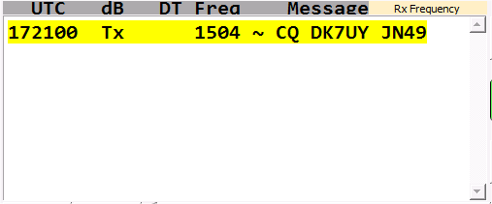

Monitor panel
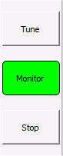
Press to generate a tuning tone, TX will switch on
Switching signal decoding on/off
Stops signal decoding

Function keys, moving the mouse cursor over a key will give you a short description.

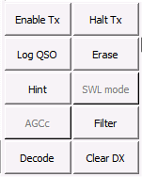

Enable TX button

This will enable the transmission of either a generated message or a free text message

Halt TX button
Interrupts any transmission immediately.
Please allow 2 sec. before hitting the Enable TX button again.

Log QSO button
Manually logs the actual QSO-data to the wsjtx.log and wsjtx_log.adi files

Erase button
Left mouse button will clean up left receive window, right mouse button will clean up right receive window, any mouse button double click will clean up both windows.

Hint button
‘Hint’ button activates four decoders each of them is based on the matched filters. Diagram below shows the way decoders being used in the JTDX software.

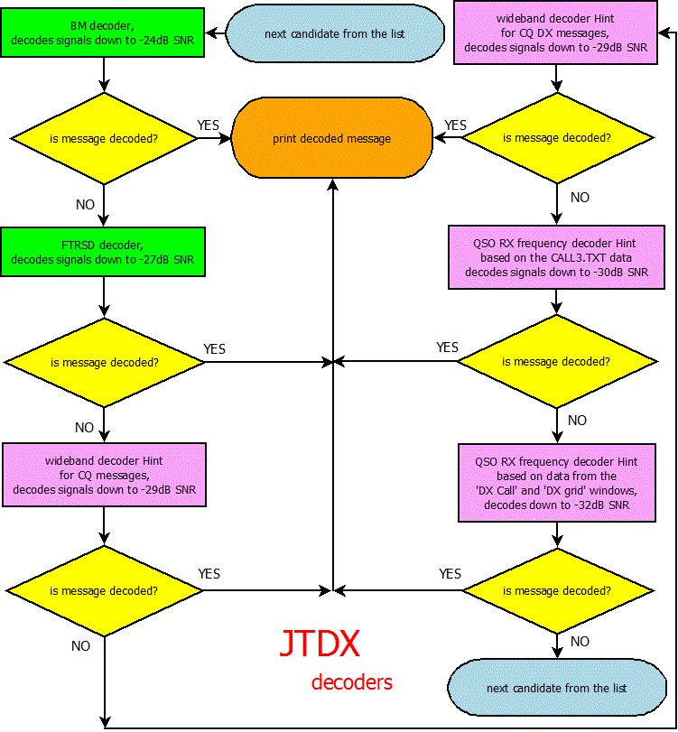

Three ‘Hint’ decoders use data from the CALL3.TXT file, fourth Hint decoder use data from ‘DX Call’ and ‘DX Grid’ windows.
First two ‘Hint’ decoders operate in wide bandwidth and focused on CQ /CQ DX messages, last two operate on QSO RX frequency and use full set of the standard messages including RO, RRR, RR73, 73: total 66 messages per each callsign from CALL3.TXT or from ‘DX Call/DX Grid’ windows.
This set of messages is encoded the same way software does it for message transmission, and each codeword is compared with the demodulated one using the correlation function.

Codeword set generation may take up to 20…50 seconds depending on the CPU frequency. This process is started once, and for last two ‘Hint’ decoders is triggered by candidate on the QSO receive frequency.
Created codeword set is allocated in the memory and any next receive interval will be decoded fast enough.
There are two thresholds used to make decision if message is decoded by ‘Hint’ properly: distance between first and second best codewords and absolute value of the correlation function.
There is the asterisk symbol ‘*’ added to the decoded ‘Hint’ messages, to let user distinguish Hint decodes from BM/FTRSD ones. This symbol is also used to ban sending decoded ‘Hint’ messages to the pskreporter server http://pskreporter.info/pskmap.html , as some of them may be false decodes.
There are unavoidable false ‘Hint’ decodes caused by high sensitivity of the ‘Hint’ decoders, all of them have really existing callsigns in the decoded message. Similar to CW/SSB weak signal reception it is up to user to make own decision if received message is the wrong one.
Number of the false ‘Hint’ decodes depends on linearity of the receive path, signal taken from SDR receiver with digital audio stream have less false decodes, number of the false decodes will be increased if there are intermodulation products in the receive path.

SWL button
SWL mode providing maximum decoding efficiency, but needs fast CPU

AGCc button
Use it only if AGC being triggered in your receiver by JT signals at beginning of the RX interval. Noise level change in the waterfall might be used as criterion showing that AGC is triggered in the receiver.

Filter button
Filter button limits JT65 signals decoding down to 400 Hz bandwidth and decoded messages output to the screen down to 100 Hz bandwidth. Filter is centered relatively to synchronization pattern (bottom frequency of JT65 green RX marker in the Wide Graph window).

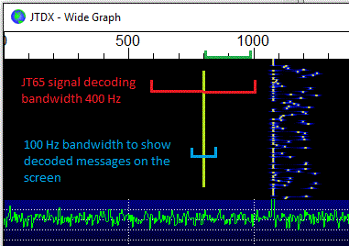

400 Hz wide bandwidth is required in overcrowded band conditions to decode and subtract loud signals that have spectrum crossed with QSO frequency.
100 Hz bandwidth for letting message come to the screen allows user to focus attention close to the receive frequency of QSO.
Number of decoding attempts is redistributed to the lesser number of candidates slightly increasing probability to decode signals if ‘Filter’ button is used.

The Filter function with adjusted bandwidth is also available for the JT9 / T10 / FT8 modes!

Decode button
Last receive interval or last played wav file will be decoded again if ‘Decode’ button is clicked. It could be useful if user changed any combination of buttons Filter/Hint/SWL mode.
Left mouse’s button double click on the Wide Graph allows to choose required frequency/JT65 signal and activates ‘Decode’ button. Probability to decode JT65 signal on this frequency will raise up as there is better algorithm used for QSO RX frequency.

Clear DX button
Use it to clean DX Call DX Grid windows if data there is not required, this way you could avoid some false hinted decodes.

Message generator panel

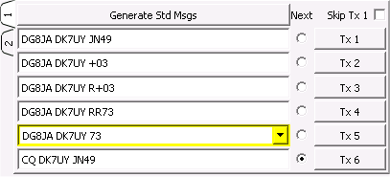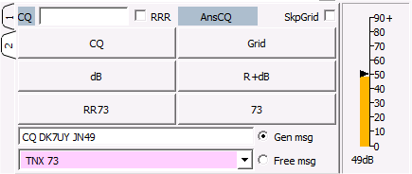
View 1
View 2
Select to skip sending grid locator
Enter 2 digits for CQ destinations like NA or AS. Replaces DX checkbox, enter DX to call CQ DX
Audio Input display, adjust your soundcard between 30 and 50db for best decoding results

The Status bar
Selected mode
Progress bar
Last logged callsign
Date
RX/TX indicator
Last message send
Number of log entries in the selected mode

The Settings-Menu

There are only a few required settings, and these, with a few optional ones, should get you started.

Start JTDX and click on File - Settings
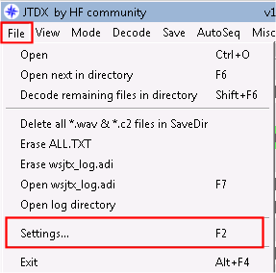

When in the Settings menu, note the arrows in the top right corner (red circle). will move the tab options across to select more tabbed options.
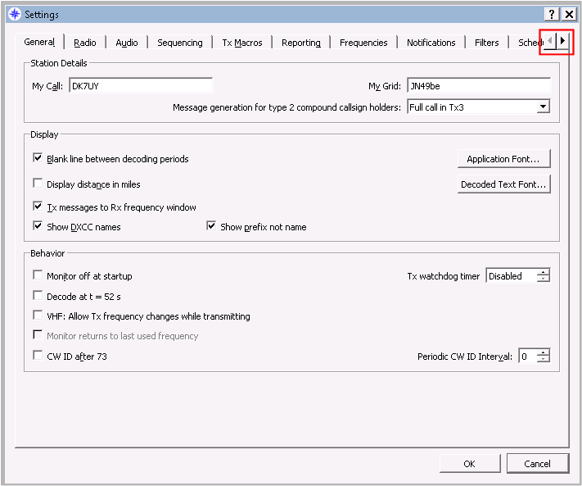
button will move to the beginning of the Settings-Menu.

General Settings

Station Detail
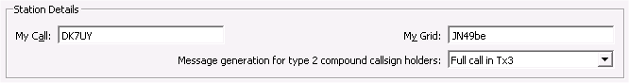

These are required as JTDX will not be able to populate fields or conduct QSOs if it doesn’t know who you are.

My Call : Your callsign
My Grid : your maidenhead grid in 4 or 6 character format. Only 4 characters will be transmitted.

Message generation for type 2 compound callsign holders:
As this is a basic setup just to get you started then unless you are using a compound callsign (eg PA/DK7UY/p) then it will probably best to leave at default.

When the system is working, and you want to operate from a different location/state/country etc then this will have a bearing.

Under Help – Short list of add-on prefixes and suffixes you will find a list of the prefixes and add-on’s.
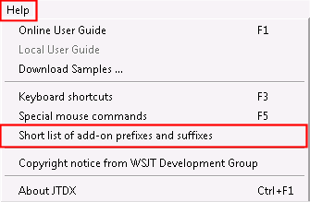

Display

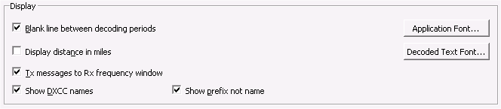

Blank line between decode periods
Checking this box inserts a line between each minute decode.

Useful if there are lots of decodes as you can see at a glance where each new decode cycle started.

Display distance in miles
Checking this box displays distance to other station in miles (unchecked is kilometres) – roughly accurate.

TX messages to RX frequency window
Puts what you transmit in the right-hand window

Show DXCC names
If checked shows entity name in left-hand window

Show prefix not name
If checked shows the entities prefix not full name

Application Font
Pull down to select the font

Decode text font
Pull down to select font in decode windows

Behaviour

Monitor off at startup
If un-checked will attempt to decode at the top of each minute

Decode at t = 52 s
Starts decoding at the 52 second mark of the minute (mainly used for VHF)

VHF: Allow frequency change while transmitting
Allows you to move Tx to another frequency during the Tx cycle, eg a late decoded message

Monitor returns to last used frequency
Not activated yet

CW ID after 73
Transmits your callsign in CW after sending 73

Tx watchdog timer
Stops transmit after a pre-determined number of minutes so, if you were to be called away and forget to deactivate Tx, you don’t cause QRM

Periodic CW ID interval
Drop down in minutes of how often your callsign is transmitted in CW

Radio Settings

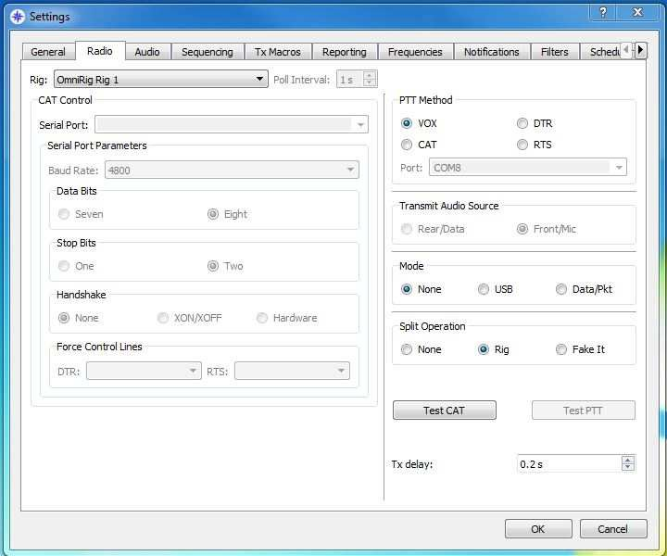

This setting page is the one that causes the most headaches and heartaches, but it really isn’t that difficult.

If you are already using a CAT controller for your radio, check its settings and write them down.

Rig:
If you’re using Hamlib then find your radio in the list (or one very close) If you’re using Ham Radio Deluxe, then select that.
If you’re using DX Lab Suite Commander then select that. If you’re using Omnirig, then select that.
If you’re not using anything, then find your radio in the list and select that. Select the CAT Control serial port parameters.
Select whichever PTT method you are using. Select Transmit Audio Source (if available)
Temporarily leave Mode and Spilt Operation to none.

Click on Test CAT
All being well, the button should turn green.
If not, check your serial settings. Right port? Right baud?

Click on Test PTT
Again, button should turn green and radio should key up.

A Special Note about Split Operation.

Split operation together with the CAT transceiver control is primarily used to prevent radiation of the AF signal harmonics, letting user to set AF signal level once and avoid constant control of this level if AF frequency is changed.

Split operation also allows transmitting JT65 signals in 0…500 Hz Wide Graph range and JT9 signals above 2500 Hz with no output power reduction and overload of AF path of the transmitter.

This functionality is inherited from WSJT-X, JTDX software will always be keeping transmit AF frequency within 1500…2000 Hz frequency range, TX VFO frequency is changed via CAT interface with 500 Hz step depending on the TX AF frequency on the Wide Graph.

There is simple example to gain understanding Split operation functionality: Let’s say TX VFO is set to 7076.0 KHz.
If Wide Graph TX AF frequency is set to 900 Hz, TX VFO frequency will be changed to 7075.0 KHz and software will supply transmitter with 1900 Hz AF signal.

If Wide Graph TX AF frequency is set to 2300 Hz, TX VFO frequency will be changed to 7076.5 KHz and software will supply transmitter with 1800 Hz AF signal.

TX VFO tuning step is equal to 500 Hz, it is the same for Split operation/Rig and Split operation/Fake it mode.

Split operation/Rig uses both VFO A and VFO B of transceiver, one for reception another for transmission.

Split operation/Fake it is designed to support transceivers with single VFO, in this mode VFO frequency will be changed for every transmission to/from receive transition and can be seen on radio screen for split A/B
An easy example to use for audio indication is with rig split “off”
Set out put audio to computer speaker, set volume to very low!!!!!! , in Dx window enter a callsign, then press the dB button this will activate an audio tone from computer speakers only, whilst the dummy Tx is taking place move the Tx brackets up and down the waterfall, and listen to the tone differences on the computer speakers?

Audio Settings

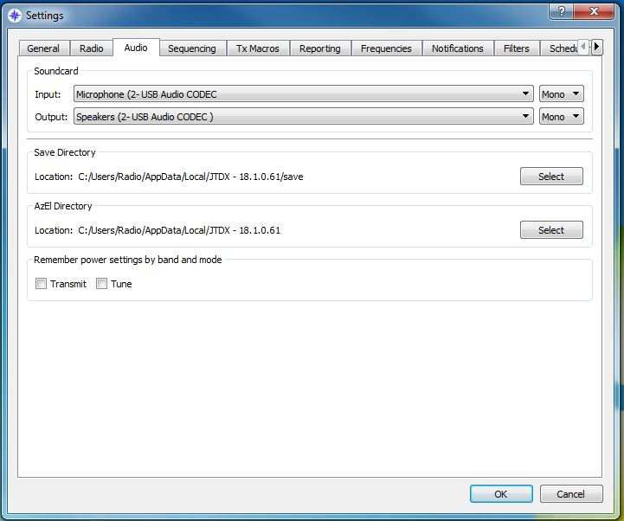

Select the Soundcard Input and Output.

NOTE: These are the devices associated with your radio, not the speakers in your computer.

Do NOT select the default Windows soundcard, as any “dings”, “pops” or “tunes” generated by Windows will be transmitted through your radio.
Please read the Online Help for full sound settings.

Sequencing

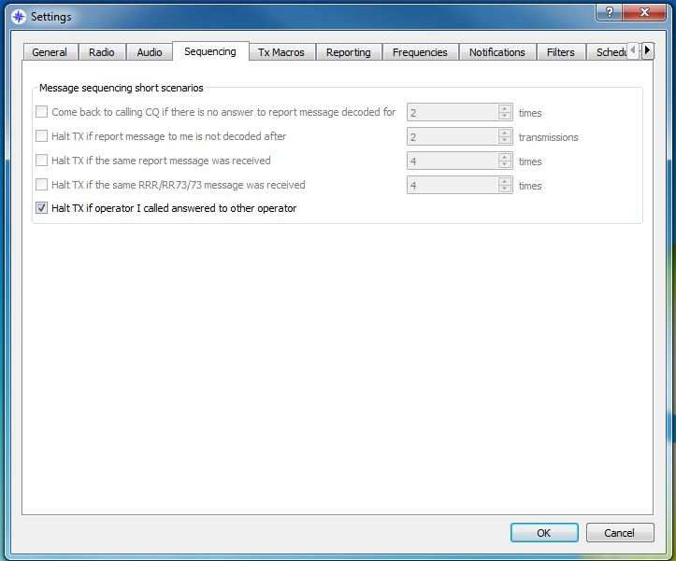

Halt TX if operator I called answered to other operator – if checked will disable TX The other functions are disabled at the moment.

Tx Macros

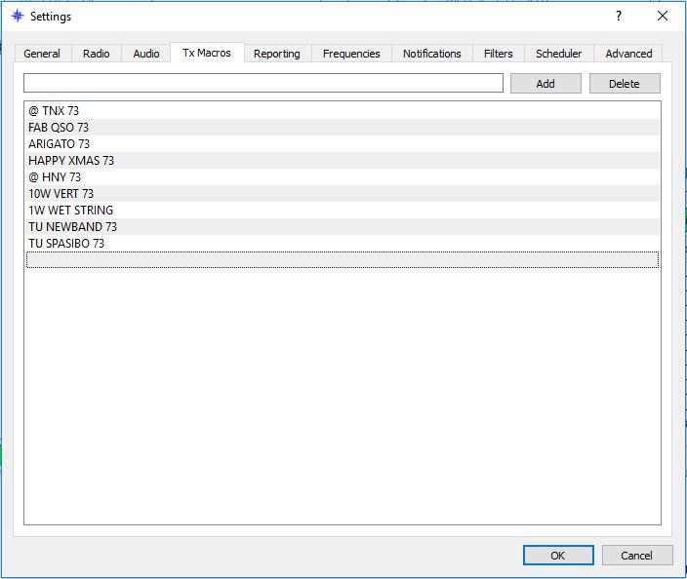

Macros are used for sending frequently used messages – examples above.
To add a new message to the list, enter the desired text (up to 13 characters) in the entry field at top, then click Add.
To delete a message, click on the message and then on Delete.

Reporting

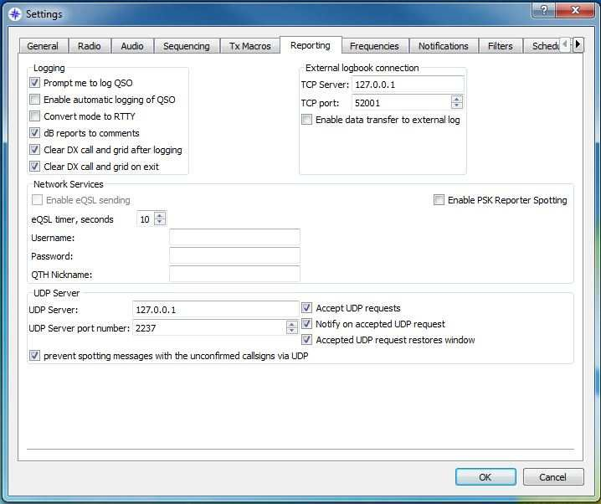

Logging
Prompt me to log QSO – if checked, popup will prompt to log QSO after sending RR73/73 Convert mode to RTTY – if checked will convert logged mode to RTTY
dB reports to comments – if checked will place received and sent dB reports into comments field of log
Clear DX call and grid after logging – if checked will clear DX call and grid after logging Clear DX call and grid on exit – if checked will clear DX and grid when exiting JTDX

External logbook connection
TCP Server: if your external logbook uses TCP enter its address here TCP port: and its TCP port here
Enable data transfer to external log – if checked enables the above 2 settings

Network Services
Enable eQSL sending – if you subscribe to eQSL.cc and would like JTDX to upload your QSOs automatically then you will need to fill in the following information and check this box.
Username: same as used to log into eQSL.cc Password: same as used to log into eQSL.cc QTH Nickname: as used on eQSL.cc
Enable PSK Reporter Spotting – if checked, will send your details and decoded reports to pskreporter.info

UDP Server
If using a program like JT-Alert (www.hamapps.com), you will need to copy these setting from that program.
UDP Server:
UDP Server port number:
Accept UDP requests : check if using JT-Alert
Notify on accepted UDP request : check if using JT-Alert Accepted UDP request restores window : check if using JT-Alert
Prevent spotting callsigns with the unconfirmed callsigns via UDP : if checked, will not pass decodes marked with ? to JT-Alert

Please note

Multiple instances of JTDX requires each instances to use a different port number 2236, 2237, 2238, 2239 etc.

Using Log4OM this requires that if JT Alerts uses port “” JTDX must be set and use a different number “Log4OM uses “2236”” JTDX set to 2237?

Frequencies

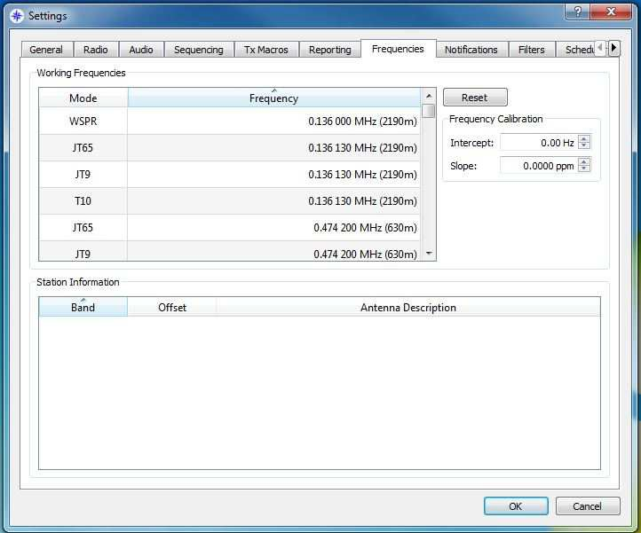

If your frequency list is blank, clicking on RESET will repopulate it with commonly agreed upon frequencies (check local regulations).

Right clicking on the lower window will allow the users antenna description to be sent to PSK reporter
e.g. 25m Long wire, 3 Element Yagi

Notifications

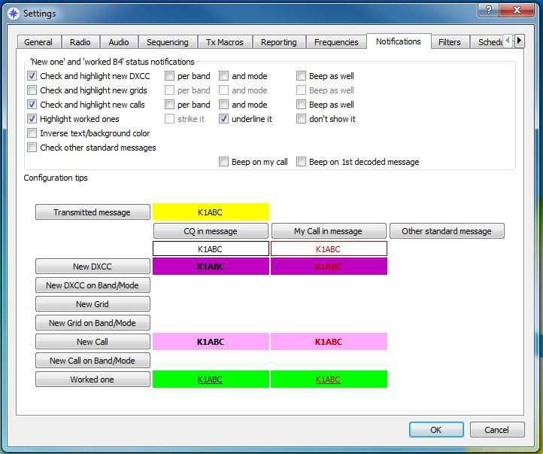

Set colours to your desired settings

Please see video demonstration on www.jtdx.tech.

Filters

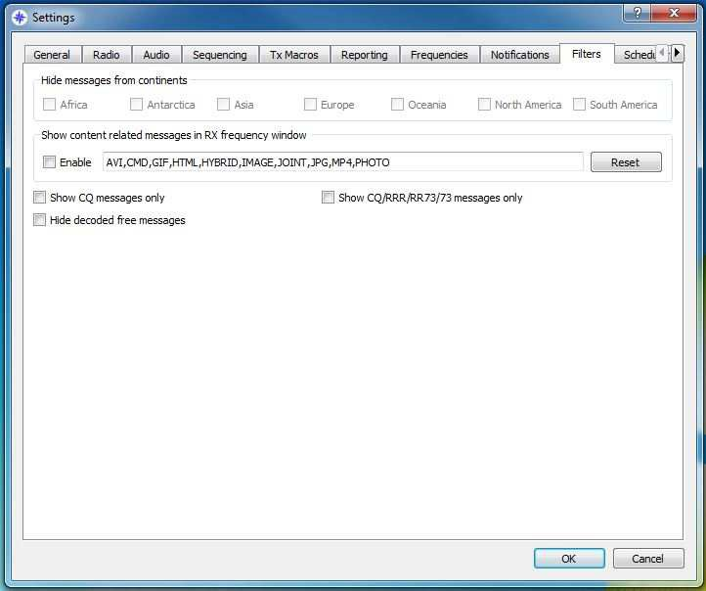

Hide messages from continents
Africa, Antarctica, Asia, Europe, Oceania, North America, South America – checking boxes will not display checked continents.

Hide decoded free messages – doesn’t show free text messages

Show CQ messages only – display only CQ messages

Show CQ/RRR/RR73/73 messages only – display only CQ/RRR/RR73/73 messages only

These feature can relieve the stress of looking at too many decodes in the windows JTDX being focused on DX and user choice allows the user to be selective in the decodes
shown, if the user wishes to contact or see contacts from ASIA only this allows that user to not be hindered by other calls, this does not stop these calls from being processed, this only does not show or show the selected items!
If the user selects any of the settings this will prevent the selected item being shown or shown in the left decodes window
If the user wishes to only see “CQ messages select CQ only”
If the user wishes to hide messages from Europe select this item There is a video demonstration of these features on www.jtdx.tech

Scheduler

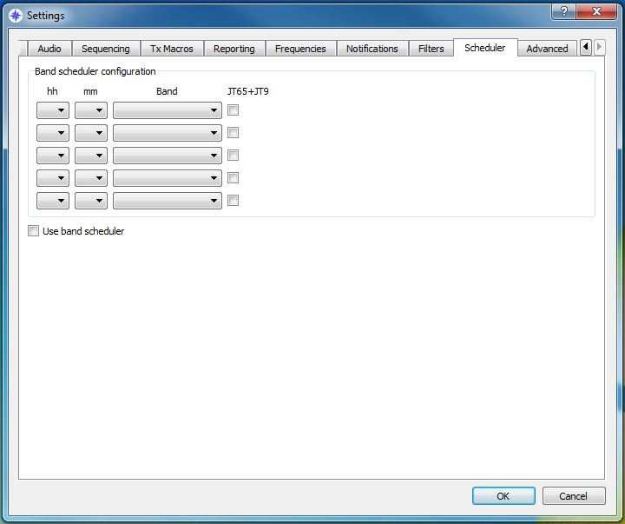

This feature is used to monitor various bands whilst the user is busy, this can be set to overnight say top band to allow a record of decodes on bands and times these bands are active for research or future contacts, in UI3 this feature has a 4 seconds tune up signal omitted on band change.

Advanced

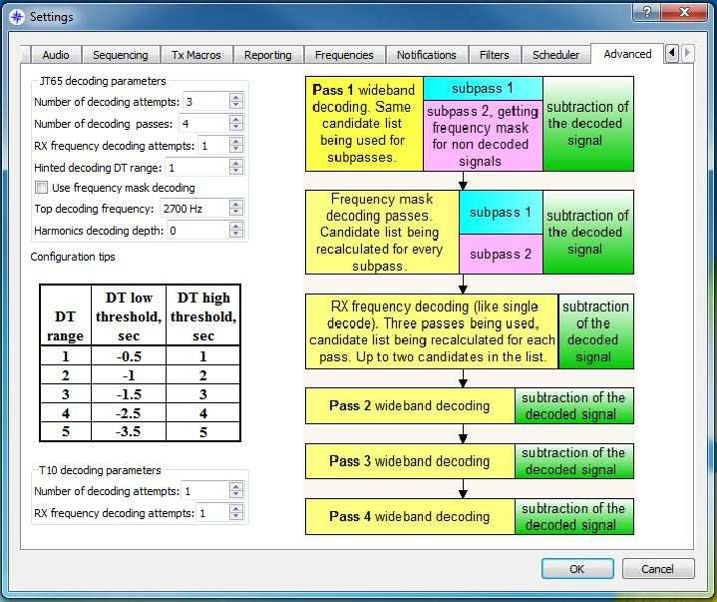

Please see video presentation at www.jtdx.tech.

Trial and error should be considered to allow the best performance and decodes. The higher the setting the more processing power is required and the longer some decodes may take to show in the decode windows.

Number of decoding attempts “wideband” the size of the user’s waterfall. Through subtractions and filters this passes or removes decoded signals to allow better processing of other signals being processed and potential decodes , default is 3. On computers with more resources this can be adjusted up or down to suit the computer.
Note: see test results excel comparisons

Decoding passes: this specifies the number of passes made on the wideband signals as can be seen in the matrix picture.

Rx Frequency decode attempts: this focuses on a narrower bandwidth surrounding your Rx brackets on the waterfall, this can be set higher for trial, but may cause more resource usage.

Hinted decode range
Use frequency mask decoding: this allows for an extra 2 decoding passes and is on by default for bands that have less than 9 signals, in comparisons this showed an increased number of decodes.

T10 decoding attempts: this specifies additional attempts at decoding T10 signals, usually the default of 1 is sufficient for both.

Top decoding frequency: This feature specifies the upper limit of JT65 decoding; this was implemented for situation on busy bands where users were calling above the usual JT65-9 Blue divider mark on the waterfall.
This setting has also the facility to automatically change modes when returning a call above the grey marker on the waterfall with a buffer zone on the blue divider line being used.

See screen shot and video at www.jtdx.tech

The Main Menu

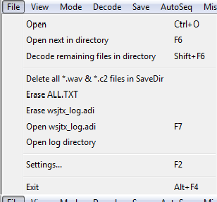File
Open and decode a saved wav-file in the SaveDir .
Delete different files.
Caution: If you delete your wsjtx_log.adi file your log is gone, forever. No undelete, only a bad feeling!
Open your logfile for manual editing.
Open the user folder with jtdx.ini, all.txt and logs.
Open the Settings Menu.

View
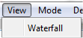
Display Waterfall On/Off

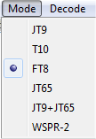Mode
Selection of the operating mode

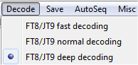Decode
Selection of the decoding algorithm

Save
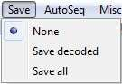
Selection of how to save messages to the SaveDir

AutoSeq
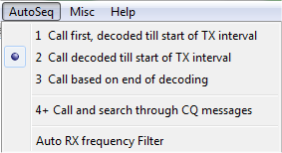
Selection of how AutoSeq will work

AutoSeq in JTDX is based on QSO history data structure where all CQ messages and all messages that have user's callsign being recorded inside.
QSO history data structure will be cleaned up if band is changed, specific callsign can be cleaned up from the history using click of the right mouse's button on the Clear DX button. Also specific callsign is cleaned up from the history at 'hisCall myCall myGrid' message transmission.
AutoSeq functionality is priority based one, priorities are being ranked according to the Notifications functionality.
AutoSeq will not respond to any 'worked B4' incoming call if there is any 'new one' criterion is selected in Notifications tab of the settings. It is up to user to respond to any incoming B4 call in the manual mode of operation.
AutoSeq will be choosing signal with the best SNR while getting two or more incoming calls with equal priority or if there is not any 'new one' criterion is selected in the Notifications tab.
JTDX AutoSeq providing multiple options where user can choose the best one according to the processing power of the CPU and user's needs.

There are three alternative modes of AutoSeq operation:
AutoSeq1 - 'Call First, decoded till start of TX interval'. In this mode AutoSeq will respond to the first incoming answer to your CQ only if it is decoded before start of your next transmission. All signals being decoded during transmission will be ignored. Such approach does let to keep one message/full interval transmission, while all late decoded messages will be ignored.

AutoSeq2 - 'Call decoded till start of TX interval'. In this mode AutoSeq will be searching for any incoming call till start of TX interval, then will answer to the best one in terms of priority and/or SNR. All incoming calls decoded during message transmission will be ignored.

AutoSeq3 - 'Call based on end of decoding'. This option can be used on fast CPUs if there is wide bandwidth being used for decoding. AutoSeq will be waiting till end of decoding then will answer to the best one in terms of priority and/or SNR. In this mode AutoSeq can start transmission with previously transmitted message and may change message during transmission. User's shall be careful while selecting this option in wideband decoding mode, as any change of TX message beyond 2nd..3rd second of TX interval will decrease chances of getting this message decoded down to zero.

AutoSeq4+ - 'Call and search through CQ messages'. This option can only be used together with option 2 (AutoSeq4+2) or option 3 (AutoSeq4+3). It is searching for incoming call and if there is no then it is searching for all decoded CQ messages to select the best one in terms of priority and/or SNR and will answer to selected CQ message.
This option providing very efficient operation in terms of QSO ratio.

AutoSeq calling CQ operation depends on the logging mode. To prevent fully automatic operation AutoSeq cycle shall be broken if there is no operator's action is performed.
In autologging mode AutoSeq switches off Enable Tx button and action from user required to switch Enable TX button back on.
In 'Prompt me to log QSO' or manual logging AutoSeq will brake cycle (will switch Enable TX button off) if QSO is not logged before end of QSO (73 message is decoded).
Hence software will not let setup operate while being unattended. AutoSeq will continue cycle of operation if user accepted QSO prior to decoding of the final 73 message.
AutoSeq1 will continue to call CQ if QSO is logged before getting the final 73 message.
AutoSeq2 and 3 search for any new incoming call while receiving 73 message ending current QSO and will answer it if QSO is logged before getting the final 73 message. It will continue to call CQ if there is no any incoming call received.
AutoSeq6 and 7 search for any new incoming call while receiving 73 message ending current QSO and will answer it if QSO is logged before getting the final 73 message. It will find and answer to the best CQ message if there is no any incoming calls. AutoSeq6 and 7 will call CQ if there is no incoming calls and no any valid CQ message decoded.

'Auto RX frequency filter' option is implemented to assist users with slow CPUs, it will simply switch on Filter button when any incoming call is received or if 'hisCall myCall myGrid' message is transmitted and will handle this frequency Filter until QSO is finished. CQ message transmission and 73 message reception will trigger switching off of the Filter button. Narrow frequency filter lets user to decode signals quickly, and AutoSeq3 mode can be used together with AutoFilter on the slow CPU.

Misc
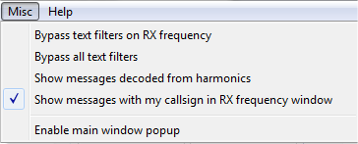
Bypasses filter set in the Settings – Filters menu
Decode harmonic signals On/Off
Shows all decoded messages with your callsign in the right window (TX messages too)
Main Window popup On/Off

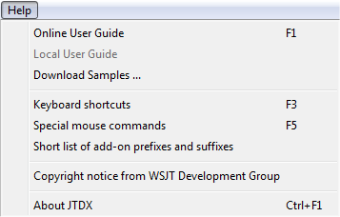Help
Link to this user guide
Keyboard and mouse commands (See bellow)
List of allowed callsign prefixes and add-ons
Copyright information

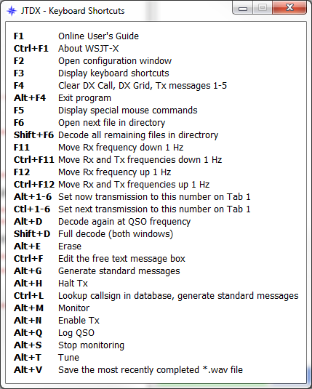
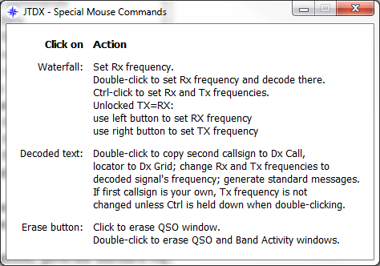

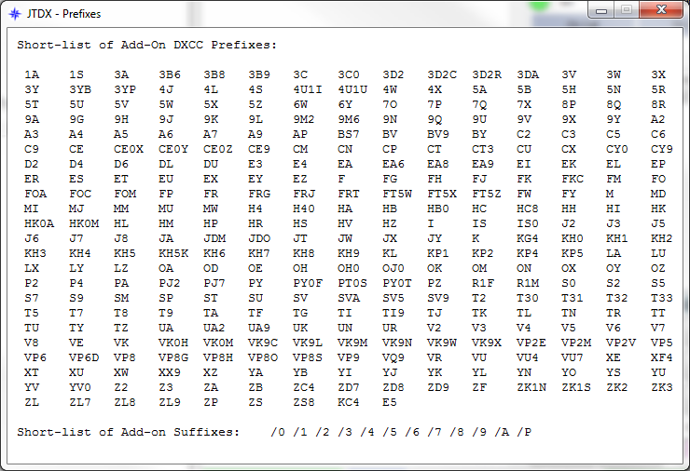

Merging internal logbook from WSJT-X with JTDX

The logs are stored at “C:\Users\%Username%\AppData\Local\WSJT-X” and “C:\Users\%Username%\AppData\Local\JTDX” folders.
The %Username% stands for your Windows login name.

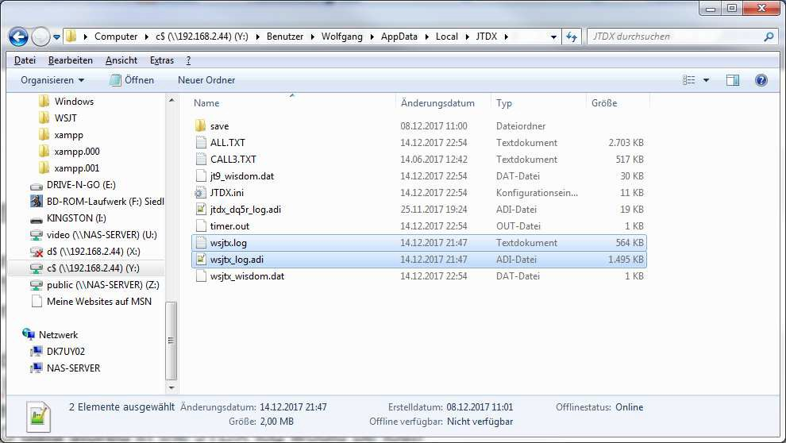

Once you did a clean installation of JTDX all you have to do is to copy the wsjtx.log and wsjtx_log.adi files into the JTDX folder.
Please check that both files are not existing in the JTDX folder before you copy them or any QSO data stored in the JTDX log would be lost!
The files have the same structure in both programs.

If you used JTDX and WSJT-X parallel on one or different PC’s, you will find the logfiles in both directories. In this scenario you have to merge the WSJT-X log into the JTDX files manually using a simple text editor. This is a two step task.
Close JTDX or WSJT-X programs if they are running. First open up the wsjtx.log file in the WSJT-X folder.
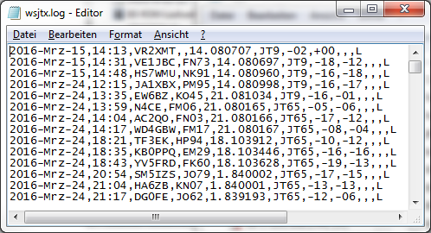

Mark everything by pressing Ctrl-a and copy to the clipboard with Ctrl-c.

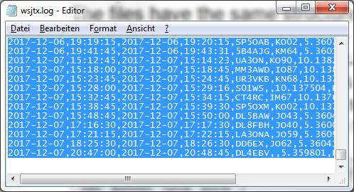

Now open the wsjtx.log file in the JTDX folder and scroll to the end of the file.

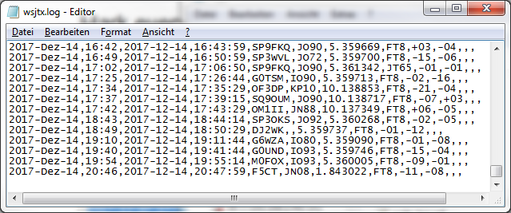

Place the cursor into the last, empty line and press Ctrl-v. The datasets will be appended to the JTDX log, it is not necessary to get them sorted in any way.
Don’t forget to save the file.

Second the wsjtx_log.adi files have to be merged in a similar way. Open the wsjtx_log.adi into the text editor.
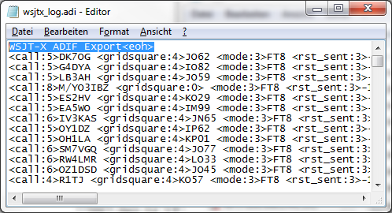

Mark the first line stating “WSJT-X ADIF Export<eoh>” only and delete it.

Mark the data left by pressing Ctrl-a and copy to the clipboard with Ctrl-c again.

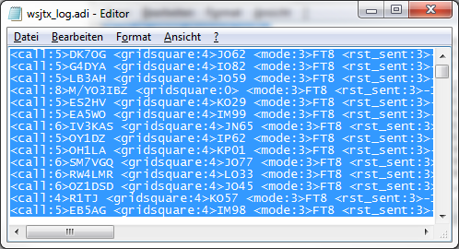

Now open the wsjtx_log.adi file in the JTDX folder and scroll to the end of the file.
Place the cursor into the last, empty line and press Ctrl-v. Save the wsjtx_log.adi in the JTDX folder and you are done.

Start JTDX and enjoy the colouring of the contacts now also including the ones done in WSJT-X before.

Supported 3. Party Programs

JT-Alert (www.hamapps.com)

Provides several audio and visual alert types based on decoded Callsigns.
- Audio and visual alerts for several alert conditions
  - Your Callsign decoded (someone calling you)
  - CQ & QRZ
  - Wanted Callsign
  - Wanted Prefix (by Ban/Mode)
  - Wanted Grid (by Band/Mode)
  - Wanted US State (by Band/Mode)
  - Wanted DXCC (by Band/Mode)
  - Wanted CQ Zone (by Band/Mode)
  - Wanted Continent (by Band/Mode)
  - Wanted CQ Marathon (by Band/Mode)

- Automatic logging to these log types when QSO is logged
  - DXLab DXKeeper
  - ACLog
  - Log4OM
  - HRD Log V5
  - Standard ADIF 2.2 file
  - MixW CSV file

There are many more features to this program that will make your using JTDX more pleasurable. Well worth the download. (Only available on Windows platform)

Loggers
There are a plenty of different logging programs available and it is far beyond the scope of these instructions to attempt to walk you through setting up any.
However, the JTDX support forum (https://groups.yahoo.com/neo/groups/JTDX/info) has many users and quite possibly one has a similar setup to you and can help with settings etc.

PSK Reporter

By Philip Gladstone, is a web server that gathers reception reports sent by various other programs, including JTDX.

The information is made available in near real time on a world map, and also as statistical summaries of various kinds. A number of options are available to the, you can request a map showing world-wide FT8 activity on all amateur bands over the past hour for example.

This map shows the stations I worked on 60m in the night from 16./17. November 2016.
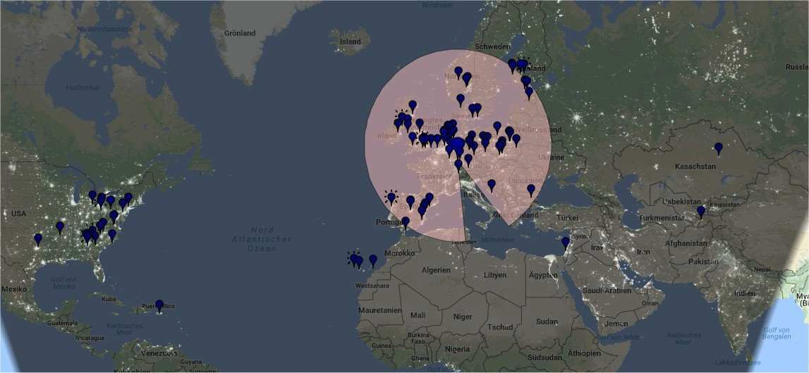

JTDX on the Web.

JTDX Support Group
https://groups.yahoo.com/neo/groups/JTDX/info

JTDX official website (Downloads, Changelogs, FAQ’s, Videos, …)
http://jtdx.tech

JTDX YouTube channel
https://www.youtube.com/channel/UCWxuJrtNLRh-CLgVqCA0XVw

